CREDIT CARD SPENDING

ANALYSIS

short line

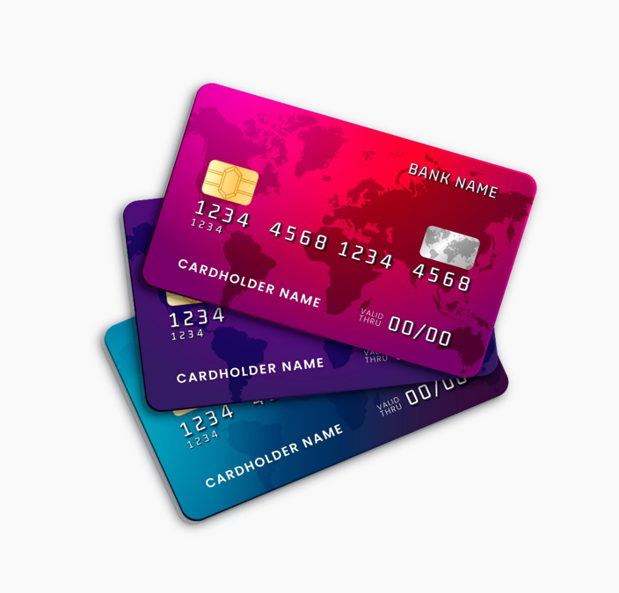

INTRODUCTION

This dataset contains insights into a collection of credit card transactions made in India, offering a comprehensive look at the spending habits of Indians across the nation. From the Gender and Card type used to carry out each transaction, to which city saw the highest amount of spending and even what kind of expenses were made, this dataset paints an overall picture about how money is being spent in India today. With its variety in variables, researchers have an opportunity to uncover deeper trends in customer spending as well as interesting correlations between data points that can serve as invaluable business intelligence.

**AIM**

The project aims to provide valuable insights into consumer behavior, trends, and patterns related to credit card transactions. This project contains a comprehensive data analysis focused on understanding and visualizing credit card spending habits in India.

**OBJECTIVE**

1. *Pattern Recognition:* By analyzing credit card transaction data, the project aims to uncover hidden patterns and trends. These patterns can provide valuable insights into customer spending behavior, seasonal trends, and peak transaction times.

2. *Customer Segmentation:* Through clustering and segmentation techniques, the project can group customers based on their spending habits, demographics, and transaction preferences. This information can be leveraged for targeted marketing campaigns and personalized customer experiences.

# **DATA OVERVIEW**

| **Column names** | **Description** | **Data type** |
| --- | --- | --- |
| id | Unique identification | int |
| City | The city in which the transaction took place. | text |
| Date | The date of the transaction | date |
| Card Type | The type of credit card used for transaction | text |
| Exp Type | The type expense associated with the transaction | text |
| Gender | The gender of the card holder | text |
| Amount | The amount of the transaction | int |
| month | The month of the transaction | varchar |
| year | The year of the transaction | int |
| day | The day of the transaction | varchar |
| Seasons | The seasons of the transaction | varchar |

.

**APPROACH USED**

1. *Data wrangling:*

In the initial phase , the data is examined to detect any NULL values or missing values . Also examined for duplicate values.

* Build a database
* Import the table datasets from csv
* Removing null values if any.
* Removing duplicates if any ( cleaning the data before analyzing).

2.  *Feature engineering:*

This will help us to generate new columns to the existing ones.

* Add a new column named month to give insights on the transactions made through the months. This will help us to answer questions based on monthly transactions.
* Add a new column named year to separate year from date so that we can have yearly transaction records.
* Add a new column named day to give insights on the transactions made on weekdays and weekends. This will help us to understand customer spending habits.
* Add a new column named Seasons to gain insight on most spending seasons. This will help us to identify which season has the highest spending.

# **DATA ANALYSIS**

1. Customer Analysis: this analysis is focused on identifying various customer segments, also having a better insight to the customer base and their preferences.
2. Trend Analysis: this analysis gives insight on various trends like seasonal trends, and peak transaction times.
3. Market Analysis: the purpose of this analysis is to understand the preferences of the customers. This provides insights to the marketing trends based on the expenses .

**BUSINESS QUESTIONS TO ANSWER**

**Q1. What is the lowest and highest amount spent on the expenses?**

*Query:* SELECT `Exp Type`, avg(Amount) FROM creditcard GROUP BY `Exp Type` ORDER BY SUM(Amount) DESC LIMIT 1;

SELECT `Exp Type`, avg(Amount) FROM creditcard GROUP BY `Exp Type` ORDER BY avg(Amount) ASC LIMIT 1;

*Ans:*  Highest

| Bills | 178627.8994 |
| --- | --- |

Lowest

| Travel | 148042.8333 |
| --- | --- |

**Q2. Who is one that spends the most and on what?**

*Query:*select Gender, avg(Amount), `Exp Type` from creditcard group by Gender, `Exp Type` order by avg(Amount) desc limit 1;

*Ans:*  Female 202809.6045 Bills

**Q3. What is the least spent expense according to gender?**

*Query:* SELECT distinct `Exp Type`, Gender, avg(Amount) AS TotalAmount

FROM creditcard GROUP BY `Exp Type`, Gender ORDER BY TotalAmount limit 1;

*Ans:*

| Travel | F | 147402.4538 |
| --- | --- | --- |

**Q4. In which month are the expenses high?**

*Query:* select distinct(month), avg(Amount) from creditcard group by month order by avg(Amount) desc limit 1;

*Ans:* April

**Q5. In which years does the spendings is at the highest and the lowest?**

*Query:* SELECT year, SUM(Amount) AS TotalAmount FROM creditcard GROUP BY year ORDER BY TotalAmount ASC LIMIT 1;

SELECT year, SUM(Amount) AS TotalAmount FROM creditcard GROUP BY year ORDER BY TotalAmount DESC LIMIT 1;

*Ans:* Lowest - 2013

Highest - 2014

**Q6. Is weekdays or weekends the most spending time?**

*Query:* SELECT

CASE

WHEN day IN ('Monday', 'Tuesday', 'Wednesday', 'Thursday', 'Friday') THEN 'Weekday'

WHEN day IN ('Saturday', 'Sunday') THEN 'Weekend'

ELSE 'Other' -- Handle any other days if present in your data

END AS DayType,

avg(Amount) AS TotalAmount

FROM creditcard

GROUP BY

(CASE

WHEN day IN ('Monday', 'Tuesday', 'Wednesday', 'Thursday', 'Friday') THEN 'Weekday'

WHEN day IN ('Saturday', 'Sunday') THEN 'Weekend'

ELSE 'Other' -- Handle any other days if present in your data

END) order by TotalAmount asc;

*Ans:* Weekday, 156202.7149

Weekend, 156923.4681

**Q7. In which season do people spend the most?**

*Query:* select distinct(Seasons),sum(Amount) from creditcard

group by Seasons order by sum(Amount) desc limit 1 ;

*Ans:* Spring, 157214.4917

**Q8. Which is the most popular card?**

*Query:* select `Card Type` , count(*) as usage_count from creditcard group by `Card Type` order by usage_count desc limit 1;

*Ans:* silver

**Q9. Which city has the highest transcactions?**

*Query:* SELECT City, count(*) AS TotalSpent

FROM creditcard GROUP BY City ORDER BY TotalSpent DESC limit 1;

*Ans:* Bengaluru

**Q10. What is the average amount spent grouped by gender and season?**

*Query:* SELECT Gender, Seasons, AVG(Amount) AS AvgAmount

FROM creditcard GROUP BY Gender, Seasons;

*Ans:*

F, Autumn, 160232.4023

F, Summer, 158671.4681

F, Spring, 163983.8284

F, Winter, 160554.5005

M, Winter, 152609.0927

M, Summer, 149424.0261

M, Spring, 149612.3818

M, Autumn, 152073.6450

**Q11. How many transactions occurred in each city for each year?**

*Query:*  SELECT City,year,COUNT(*) AS TransactionCount

FROM creditcard GROUP BY City, year limit 5;

*Ans:*

Delhi, 2014, 2101

Mumbai, 2014, 2116

Bengaluru, 2014, 2196

Bengaluru, 2015, 814

Delhi, 2015, 890

**Q12. What are the top 5 cities based on the total amount spent?**

*Query:*  SELECT City, SUM(Amount) AS TotalAmount

FROM creditcard GROUP BY City ORDER BY TotalAmount DESc LIMIT 5;

*Ans:*

Mumbai, 576751476

Bengaluru, 572326739

Ahmedabad, 567794310

Delhi, 556929212

Kolkata, 115466943

**Q13. What are the peak spending days for each season?**

*Query:* SELECT

Seasons,

day,

SUM(Amount) AS TotalAmount

FROM creditcard

GROUP BY Seasons, day

ORDER BY Seasons asc,TotalAmount DESC;

*Ans:* Autumn, Saturday, 159347559

Spring, Tuesday, 179413637

Summer, Sunday, 97117714

Winter, Thursday, 179724441

**Q14. How do yearly spending patterns differ across various card types?**

*Query:* SELECT

year,

`Card Type`,

SUM(Amount) AS TotalAmount,

AVG(Amount) AS AvgAmount,

COUNT(*) AS TransactionCount

FROM creditcard

GROUP BY year, `Card Type`

ORDER BY year, `Card Type`;

*Ans:* # year Card Type TotalAmount AvgAmount TransactionCount

2013 Gold 144740555 153489.4539 943

2013 Platinum 155964176 160622.2204 971

2013 Signature 161225096 161872.5863 996

2013 Silver 151714057 149178.0305 1017

2014 Gold 600688076 154458.2350 3889

2014 Platinum 600077102 155742.8243 3853

2014 Signature 606750478 155856.7886 3893

2014 Silver 647198377 155726.2697 4156

2015 Gold 239110905 155772.5765 1535

2015 Platinum 251597741 159846.0870 1574

2015 Signature 245065531 157294.9493 1558

2015 Silver 270701279 162388.2897 1667

**Q15. How can we segment customers based on their spending habits, and which segments are most valuable?**

*Query:* SELECT Gender, `Card Type`, SUM(Amount) AS TotalAmount, COUNT(*) AS TransactionCount,

ROUND(AVG(Amount), 2) AS AvgTransactionAmount,

ROUND(SUM(Amount) / COUNT(*) * 100, 2) AS ValueIndex

FROM creditcard

GROUP BY Gender, `Card Type`

ORDER BY TotalAmount DESC, ValueIndex DESC;

*Ans:*  Gender Card Type TotalAmount TransactionCount AvgTransactionAmount ValueIndex

F Silver 602433469 3773 159669.62 15966961.81

F Signature 548005149 3368 162709.37 16270936.73

F Platinum 531940229 3252 163573.26 16357325.62

F Gold 522932183 3287 159091.02 15909102.01

M Platinum 475698790 3146 151207.50 15120749.84

M Silver 467180244 3067 152324.83 15232482.69

M Signature 465035956 3079 151034.74 15103473.73

M Gold 461607353 3080 149872.52 14987251.72

**Q16. What are the peak spending days, and how do they compare to other days in terms of total and average spending?**

*Query:* SELECT day, SUM(Amount) AS TotalAmount, AVG(Amount) AS AvgAmount, COUNT(*) AS TransactionCount

FROM creditcard GROUP BY day ORDER BY TotalAmount DESC;

*Ans:* # day TotalAmount AvgAmount TransactionCount

Sunday 596345367 156438.9735 3812

Tuesday 588289572 159126.2029 3697

Saturday 588112970 157417.8185 3736

Friday 582828807 156716.5386 3719

Thursday 574399018 154491.3981 3718

Monday 573626475 154408.2032 3715

Wednesday 571231164 156287.5962 3655

**Q17. How does the use of different card types vary with seasons, and which card type is preferred in each season?**

*Query:* SELECT `Card Type`, Seasons, SUM(Amount) AS TotalAmount, AVG(Amount) AS AvgAmount

FROM creditcard GROUP BY `Card Type`, Seasons

ORDER BY Seasons, TotalAmount DESC;

*Ans:*

Card Type Seasons TotalAmount AvgAmount

Signature Autumn 271318873 158944.8582

Silver Spring 320781507 157400.1506

Silver Summer 161647085 155131.5595

Silver Winter 327792722 157896.3015

# **CONCLUSION**

In conclusion, the findings from this report offer valuable insights for credit card companies to refine their targeting strategies based on user demographics, preferences, and seasonal trends. Understanding these patterns can aid in tailoring services to meet the diverse needs of distinct consumer segments in the dynamic landscape of credit card usage in India.

* Female spends are more than Male and has high values transactions under Expenses Type Bills.
* This insight can assist credit card companies in refining their targeting strategies based on specific credit card types to better cater to distinct customer segments.
* While there is no significant disparity in the total amount spent among the various types of credit cards, the Silver credit card stands out with the highest total expenditure compared to the other three card types.

The Data provided in the dataset helps in identifying venues for Credit Card business expansion.

***THANK YOU***

short dash